BIOLOGY TEMPLATE
This template is provided separately as a Word document. Copy the template into new document and use for both the thesis proposal and final thesis.

BIOLOGY TEMPLATE: title of thesis--MAke sure the top line
is longer Than the second line

A Thesis

by

YOUR NAME

Submitted to the Graduate School
of Texas A&M University-Commerce
in partial fulfillment of the requirements
for the degree of
MASTER OF SCIENCE
[December] [May] [August] 20XX
BIOLOGY TEMPLATE: TITLE OF THESIS--MAKE SURE THE TOP LINE
IS LONGER THAN THE SECOND LINE

A Thesis

by

YOUR NAME

Approved by:
Advisor: Bob Brown
Committee: Jim Johnson
Jill Smith
Joe Perry
Head of Department: Kathy Jones
Dean of the College: Jane Doe
Dean of the Graduate School: Jennifer L. Schroeder

Copyright © 20XX

Your Name

ABSTRACT

BIOLOGY TEMPLATE: TITLE OF THESIS--MAKE SURE THE TOP LINE
IS LONGER THAN THE SECOND LINE

Your Name, MS
Texas A&M University-Commerce, 20XX

Advisor: Name of Your Advisor, EdD or PhD

Text begins here, two double spaces below the advisor line. Your proposal abstract should include the purpose, literature review, and procedures.
In your final thesis, the results and conclusions are added. For many researchers, relevant articles are selected based on the material presented in the abstract; therefore, it is important to provide as much useful information as possible in as few words as possible. The abstract should be doubled-spaced and text left justified, as is the remainder of the thesis.
Keywords: Keywords are optional.

ACKNOWLEDGEMENTS
Although this page is optional, the Graduate School encourages you to thank those people who helped you along the way. In your proposal, include this page even if you do not fill it out until the final thesis. Please keep your acknowledgements to one page.

TABLE OF CONTENTS
LIST OF TABLES viii
LIST OF FIGURES ix
CHAPTER
INTRODUCTION #
Subsection (if applicable) #
Subsection (if applicable) #
MATERIALS AND METHODS #
Subsection (if applicable) #
Subsection (if applicable) #
RESULTS #
Subsection (if applicable) #
Subsection (if applicable) #
DISCUSSION #
Subsection (if applicable) #
Subsection (if applicable) #
LITERATURE CITED #
APPENDICES #
Appendix
- Title of Appendix #
- Title of Appendix #
VITA #

LIST OF TABLES
TABLE
- If a table title is 2 or more lines, the entry in the List of Tables should always be double spaced and aligned like this #
- Replace words in red with your text #
- #
- #
- #

LIST OF FIGURES
FIGURE
- If a figure title is 2 or more lines, the entry in the List of Figures should always be double spaced and aligned like this #
- Replace words in red with your text #
- #
- #
- #

INTRODUCTION

Begin the details of the INTRODUCTION. Each chapter must be formatted in the same way with ALL pages numbered at the top right with Arabic numerals beginning on THIS page. All pages before THIS page are in lower case Roman numerals.
You are not required to use these exact section headings. Be sure to communicate with your advisor to determine which headings will best serve the purpose of the paper.
Normally, the introduction begins with a literature review that leads into a description of the purpose or objectives for the current study, the significance of the study, and the hypotheses to be tested.
Common names for organisms may be used, but the Latin name (genus and species) must be specified at their first mention. Latin names must be in italics. Use standard scientific abbreviations for units of measure. Do not use footnotes in the body of the thesis. Do not use direct quotes.
Review of the literature
This section consists of a minimum of 1-2 paragraphs discussing the statement of the problem as it relates to your research. References to scholarly literature that outline the problem and illustrate the need for further research are desirable.
Purpose of the study
This section consists of a minimum of 1-2 paragraphs addressing the purpose and justification for completing the study. Part of justifying the study is discussing relevant scholarly literature. You do not need to provide an exhaustive summary here, but maybe briefly mention researchers who have studied your problem/topic and state that the research will be discussed in more detail in the literature review.
Significance of the study
The significance of the study should accomplish three tasks:
- Describe the gap in the literature.
- Describe how this study proposes (at least partially) to fill that gap.
- Demonstrate that the researcher is competent to conduct this study.
These tasks will require a reasonably thorough review of the literature to demonstrate knowledge of the subject to be studied. Some of the literature reviewed in next chapter may be contained in this section of the document as well.
Hypotheses and specific aims
The hypothesis is “the researcher’s prediction, derived from a theory or from speculation, about how two or more variables will be related to each other” (Gall et al. 2007). Always provide an introduction for numbered and bulleted lists:
- Begin numbered lists at the ½-inch indent and continue the sentences aligned under the first letter of the first line.
- If there is only one hypothesis, change the subheading to Hypothesis and do not number the hypothesis, include it as part of the paragraph.
- Specific Aims
  - Below each hypothesis, state specific aim(s). Each hypothesis can have more than one specific aims. While formulating specific aims, independent and dependent variables must be selected carefully to match variables in hypothesis. Specific aims may state the primary methodology that been used.

MATERIALS AND METHODS
Pagination will always be at the top right on each page throughout the proposal or thesis through your Vita, which is the last page of your document.
This chapter should describe all of the methods used to collect and analyze the data. Enough detail must be provided that anyone reading the methods should be able to replicate the study. Describe any apparatus that was used and provide figures as appropriate. Describe what was measured and how it was measured. For field studies there should be a description of the study areas used. For lab studies, the source of materials must be identified. Be sure to identify the make and model number of important pieces of equipment and the suppliers of critical reagents.
Subtopic 1
Depending on your thesis topic, it may be helpful to you and the reader if the material is organized by topics and subtopics. Use of different levels of heading can help the reader comprehend the material more easily and it can help you, as the author, keep the information flowing smoothly.
Subtopic 1a
Maintain consistent capitalization and formatting for each level of subheading/subtopic.
Subtopic 1a1
Indentation, bold text, italicized text, and varied punctuation can help you to differentiate easily between different levels of heading.
Subtopic 1a2
Something to consider, however, is if you only use one subheading within a specific section, then perhaps the subheading is not needed.
Subtopic 1b
Beware of widows and orphans. Section headings should not be alone at the bottom of the page. If a page break separates the heading from its content, push the heading onto the next page.
As you write your thesis, consider what organization and information would make sense to the reader. Make sure your formatting choices are consistent and make it easy for the reader to read and understand the material.

RESULTS
This chapter should describe the results of the study. For most projects, the data are presented as figures and tables. The text of the results section should describe the important trends and/or features shown by the figures and tables. Do not simply reiterate all the details of the table or figure. Provide statistical analyses whenever appropriate.
All tables and figures must be mentioned no further than 1½ pages before the table or figure appears in the document. If a table of figure is embedded within the text of the document, insert at least three single-spaced lines before and after tables and figures. If a table must be converted to landscape format to make it fit on the page, the top of table should be oriented to the left margin. The page number on landscape pages should be formatted in the same place as other page numbers when the page is rotated counter clockwise. When the pages are printed in the bound copy, the page number needs to appear top right like the others. Here is a website that may help: https://uknowit.uwgb.edu/page.php?id=26346
All tables have a title that appears above the table that is written in sentence style. Number tables consecutively using Arabic numbers (1, 2, 3). Do not use vertical borderlines and use minimal horizontal borderlines. See the table examples on the following pages for reference. If a table is continued to another page or pages, include the table number followed by “(continued)” and a period. Include the table title and the top header row of the table. See the example on the following page.
All figures have a caption that appears below the figure that is written in sentence style. Number figures consecutively using Arabic numbers (1, 2, 3). Note, figures should not have an outside border nor should the figure caption be included in the figure itself.

Table 1. Summary of the best fit logistic regression model based on AICc. This procedure was used to predict the survival of monarch eggs or larvae based on the abundance of arthropod groups found on control host plants where the proportion of predators to non-predators was low. Concordance of this model was 31.6%.

Parameter | DF | Estimate | Standard Error | Wald  Chi-Square | Pr > ChiS q
Intercept | 1 | -1.2480 | 0.2236 | 31.1489 | <0.0001
RIFAª | 1 | -3.6684 | 2.4628 | 2.2188 | 0.1363
ªParameter confidence interval approaches infinity and is overestimated.

Table 2 (continued). The fledging success of swallows nesting in culverts and bridges in northeast Texas between 1998 and 2002.

 | Bridges  (mean + std. dev) | Culverts  (mean + std. dev) | Kruskal-Wallis  Test X² (1 df) | p-value
2001 first broods (young chicks) | 4.25 + 0.23 | 5.23 + 1.25 | 6.55 | 0.010
2001 second broods | 3.61 + 0.33 | 4.77 + 0.56 | 1.12 | 0.320
2002 first broods | 5.01 + 0.25 | 5.11 + 0.66 | 0.69 | 0.864
2002 second broods | 2.69 + 0.52 | 3.50 + 0.97 | 1.35 | 0.264

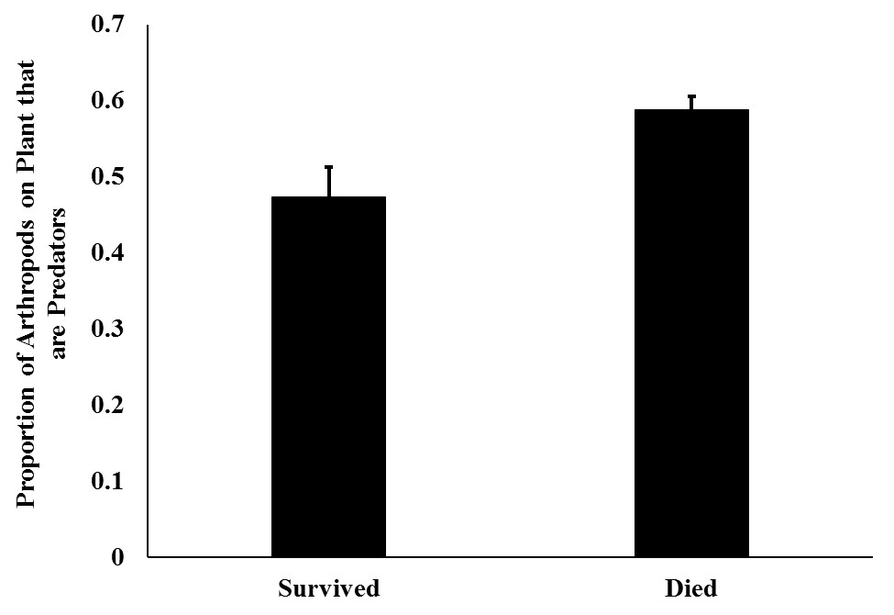
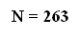
Figure 1. Control host plants upon which monarch larvae survived to the third instar had fewer predators relative to the total number of arthropods on the plant than did host plants upon which
monarch larvae failed to reach the third instar. Kruskal-Wallis ANOVA, Chi-square Approximation, X² = 6.7482, df = 1, p = 0.0094. Numbers over bars are sample sizes.

You must be careful not to violate the copyright laws of the United States. The inclusion or adaptation of part or of an entire work (e.g., a figure, or data) by another author may require that written permission from the copyright holder be obtained. If copyright permission is required, include the author and source information as a note to the table or at the end of a figure caption and must state “Reprinted with permission” or “Adapted with permission.” See the Publication of the Research: Copyright Issues” in the Graduate School’s Thesis and Dissertation Submission Guide for more information regarding compliance with copyright laws.

DISCUSSION
This chapter describes the implications of the results relative to the existing literature. Provide interpretation of the results and support these statements with corroborative evidence from current literature. The final paragraphs should provide a brief summary and possible future directions for research.

LITERATURE CITED
Please format the literature cited section as explained in the Literature Cited section above. Use a hanging indent to format entries. The hanging indent can be accessed by selecting text, then right clicking, and going to “Paragraph.” At the “Indentation” section, click on the drop box under “Special” and select “Hanging.” Use .5 inches if as the indention setting if it does not default to that setting.
NOTE: As in text, widows and orphans in references are not acceptable. A new reference with only one line at the bottom of the page should be moved entirely to the next page. Similarly, the last line of a reference should not be left to stand alone at the top of a page. Instead, move an additional line of text to accompany that line.
A three-line reference is sometimes difficult because you cannot leave one line on a page. At least two lines must be on each page so you may have to move the entire reference to the next page, leaving a blank line or two at the bottom of the previous page.

Appendices are optional and used for supplementary material. Include this cover page unless you have only one appendix, then use the format for an appendix title page, as shown on the next page, without the appendix designation.

APPENDICES

.

Each appendix must have a title page. Appendix title pages come before each appendix document. All appendix material must be within prescribed margins and be readable in size and legibility (no smaller than 7 pt. font). Tables and figures must conform to the same formatting requirements as when they are included in the body of the manuscript.

APPENDIX A

TITLE OF APPENDIX A

TITLE OF THE APPENDIX A DOCUMENT

Place the appendix title at the top of the first page only of the appendix document page. The title should be centered, in all capital letters and not bolded.

APPENDIX B

TITLE OF APPENDIX B

VITA
Though many students already have a resume-style vita, the Graduate School requires students to publish a paragraph-style vita instead. If you have difficulty drafting your vita, please contact TDS@tamuc.edu for a sample vita.
Some of the information you may want to include in your vita is as follows:
- your educational background for all previous degrees, beginning with your bachelor’s degree and ending with the current degree you are obtaining from Texas A&M University-Commerce.
- professional experience,
- publications, and/or
- business or academic information.
Do not include personal information such as date of birth, parents’ names, or your personal address in order to protect your privacy. Please ensure the name you include in your vita matches the name you have used on your title page.
Please include a permanent address (at the bottom of the page) that is good for two years. A professional/work address or A&M-Commerce department address are recommended rather than a personal address in order to protect your privacy.

Single-spaced at bottom of page
Contact information
Email:

